## ESPRIT_MAT_Color[1][Image result for school water bottle](http://www.google.co.uk/url?sa=i&rct=j&q=&esrc=s&source=images&cd=&cad=rja&uact=8&ved=0ahUKEwiFxIqgw-DQAhVBOxQKHbDgC-oQjRwIBw&url=http://waddleeahchaa.com/2012/08/08/back-to-school-pba-free-water-bottles/&bvm=bv.140496471,d.ZGg&psig=AFQjCNGEdbr9jjYskn0XR9Jlvc28clgoCg&ust=1481146585123746)

**Homework**

This term we will be sending home electronic weekly homework, in addition to daily reading. Your child will be provided with a log in to Education City and we will send home one electronic challenge each week. This will be linked to maths, English or topic teaching. We will also send home one half termly creative challenge which will link to our year group topics, (Although we are asking your child to complete one electronic challenge per week, if your child chooses they can complete more than one).

**During the next half term our new topic is:**

Spring 1-What colours make you feel happy/sad?

Spring 2-What would you find on the farm?

I 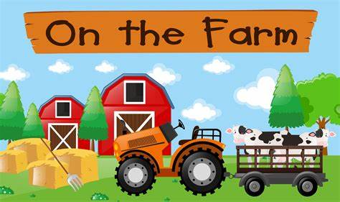

We will be:

* Learning about different ways to stay safe.
* Practising our scissor skills.
* Exploring colour using different media and materials.
* We will continue to learn to dress and undress. Please help us with this at home!
* Reading books discussing types of feelings and animals that live on the farm.
* Recognising and ordering numbers and matching numbers to quantities.
* Painting and making models of different types of animals.
* If you have any books or objects that we could use during our topic we would be very grateful if your child could bring these in to share with their friends.

**English speaking board**

Is designed to improve communication by developing speaking and listening skills. We will be continuing to share and learn different action rhymes and songs.

Our two rhymes will be:

Spring 1- I can sing a rainbow

Spring 2 – Old McDonald had a farm

What a fun packed half term we will be having. If you require any more information please speak to a member of the Nursery team.

Thank you.

**Dates for your diary:**

Nursery Application closing date:

Art Exhibition- more information to follow

Mother’s day celebration Assembly-

Easter singathon/bonnet parade –

Farm on wheels visit

Please ensure that your child brings a water bottle to school EVERYDAY. This must contain WATER ONLY.

**Housekeeping**

A donation towards school fund would be gratefully received. This is £1.00 and is used to give great enrichment opportunities to your child. This should be paid via parent pay

Please send in a box of tissues and a packet of baby wipes for your child to use in school.

As the weather is still cold, please ensure that your child has a hat and a pair of gloves to leave in school as well as their wellies.

***[](https://www.google.co.uk/imgres?imgurl=http://www.ordnancesurvey.co.uk/blog/wp-content/uploads/2012/10/blog-Oct-half-term-wellies1.jpg&imgrefurl=http://www.ordnancesurvey.co.uk/blog/?attachment_id%3D8988&docid=J-aTRgohBOe7ZM&tbnid=yCGkG37GOcwqMM:&w=2880&h=1920&ei=DvaRVJnXConyPP3hgJAO&ved=0CAIQxiAwAA&iact=c)***

**“If you can dream it then you can do it! Now, go out there and change the world”**

**Nursery Newsletter – Spring 2021**

**We hope you had a wonderful Christmas and New Year!**