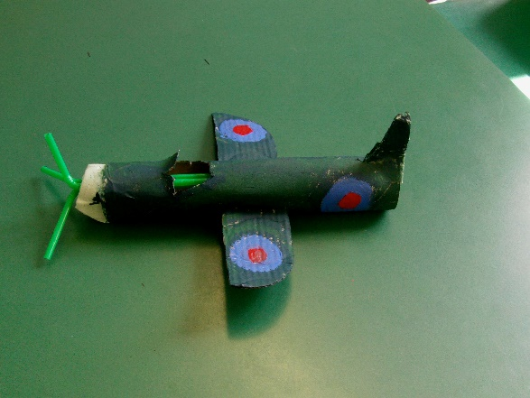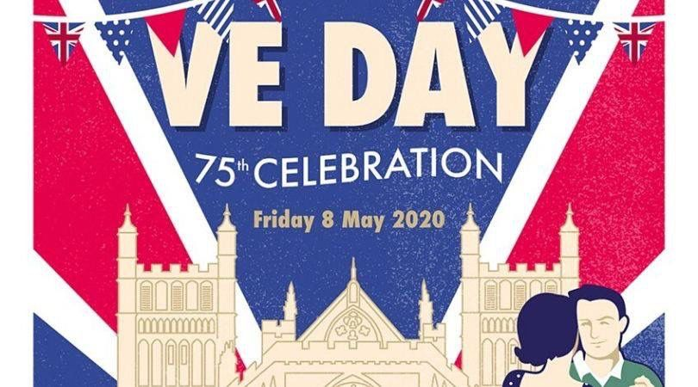

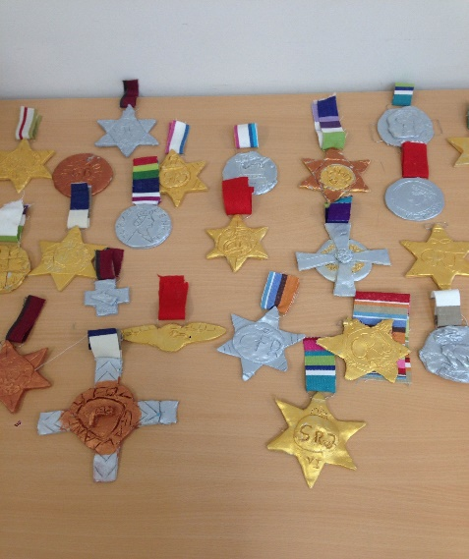

**Have a picnic or garden party. Decorate your garden with bunting and listen to some 1940’s music such as that of Glenn Miller.**

[**https://www.youtube.com/watch?v=0PB6b1OiDKg**](https://www.youtube.com/watch?v=0PB6b1OiDKg)

**Why not learn the**

**jitterbug!**

[**https://www.youtube.com/watch?v=EDeg7aovHW4**](https://www.youtube.com/watch?v=EDeg7aovHW4)

**Wear red, white or blue!**

**Make or draw medals or a spitfire using paper, card or junk modelling.**

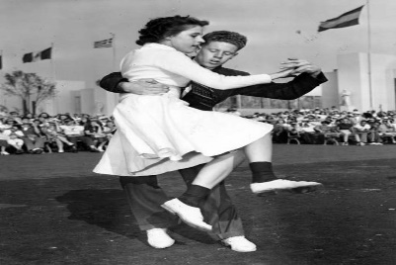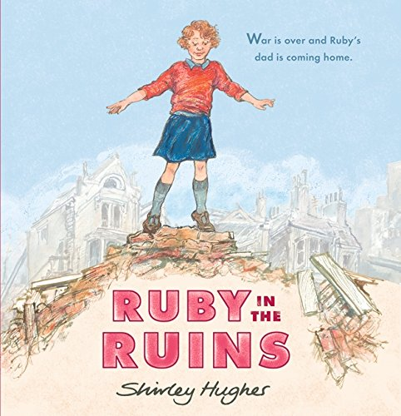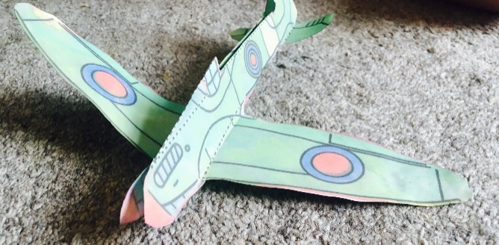

**Watch and listen to the story ‘Ruby in the Ruins’ by Shirley Hughes**

[**https://www.youtube.com/watch?v=DCkFRSCS1wc**](https://www.youtube.com/watch?v=DCkFRSCS1wc)

**Send your photos to your year group email so that we can share them on Facebook.**

**Watch the broadcast announcing the end of the war from Winston Churchill.**

[**https://www.youtube.com/watch?v=efvwJjzqKUk**](https://www.youtube.com/watch?v=efvwJjzqKUk)

**Can you video yourself being Winston Churchill and announce the end of the war? Maybe you could write a newspaper article about it!**