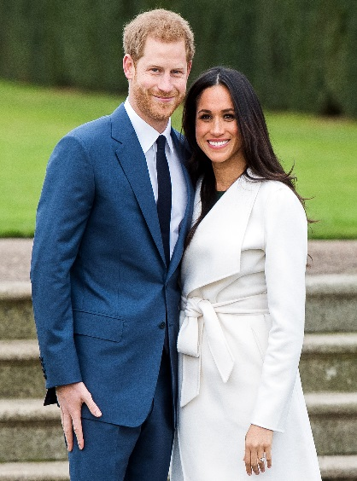

A Royal Celebration Lunch
17th May 2018

Main
Roast Turkey & Stuffing or Pizza Slize
Served with a choice of potatoes
And vegetables
Dessert
Choice of cupcake or shortbread
served with a choice of drink

