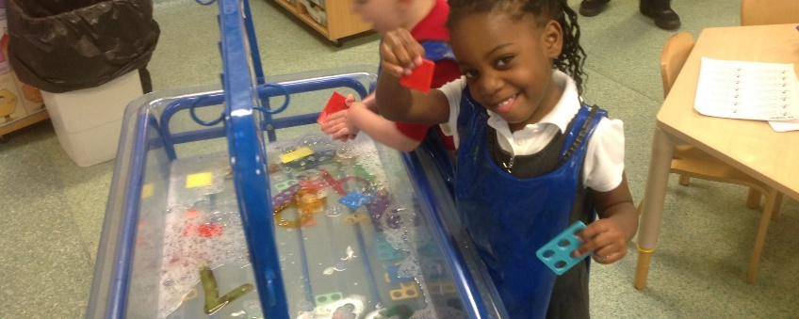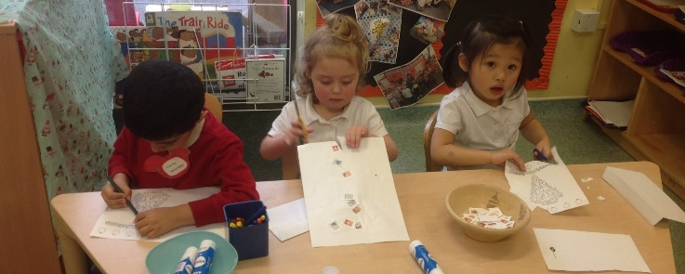

**For children/parents wishing to take 30 hours of early education:**

* All parents must check their eligibility for funding using the eligibility checker at:

[www.childcarechoices.gov.uk](http://www.childcarechoices.gov.uk)

* If eligible, you will be provided with a code, which you must give to school. *This is important as we can use this code to ensure funding for our Nursery.*

**For parents not eligible for the 30 hours government funding, we are offering to fund your child’s 30 hour placement providing your child maintains a good level of attendance! Please speak to a member of the Nursery or Office team to register your interest!**

*‘If you can dream it, then you can do it! Now go out there and change the world…’*

*Walt Disney*

**For children starting in September, parents have 2 options:**

* 15 hours (Monday to Friday – 9:00am – 12:00pm)
* 30 hours (Monday to Friday – 9:00am – 3:00pm)

**From September 2018, we will be funding full time Nursery places!**

**Important information regarding your child’s Nursery funding!**