Reviewed arrangements
Our thorough whole school risk assessment has been reviewed in line with the latest Schools COVID 19 Operational Guidance. This risk assessment also details the contingency plan that Northwood Broom Academy may be asked to put into place as a result of an outbreak of the virus.
WHAT YOU NEED TO KNOW
Entrance/exit to school | - Your child is allocated an entrance:  - Northwood Park road dropped off/collected at Nursery black gate (Nursery)  - Northwood Park road dropped off/collected at the lower black gate (Reception)  - Northwood Park road dropped off/collected at the main upper black gate (Key Stage 1)  The map below details these entrances.  - If children arrive late, they must gain entry to the Academy via the main office.

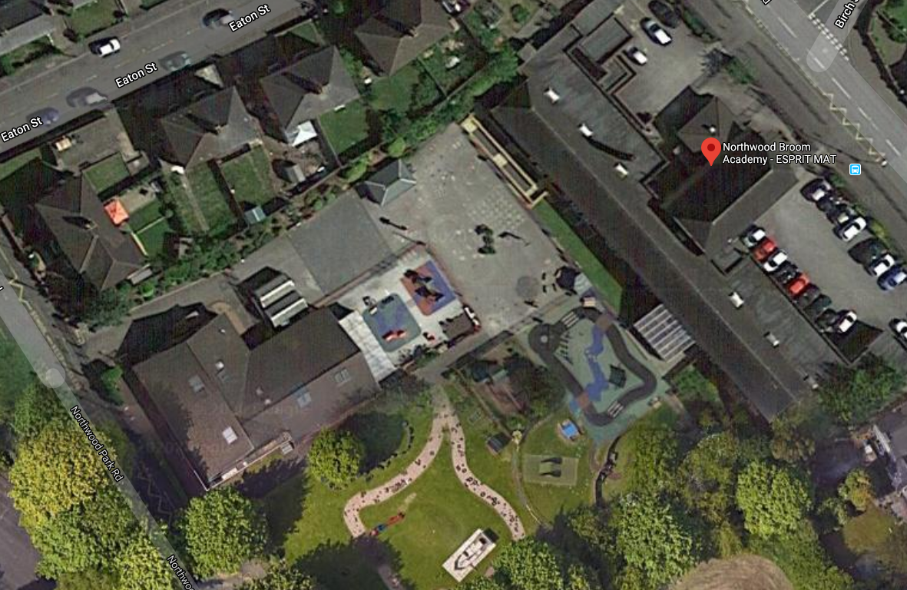
Nursery gate
Main upper black gate
Lower black gate
BASC | - Before and After school provision (BASC) can be pre-booked at a cost for ALL PUPILS from the hours of 7.30am until 5:45pm.  - We offer this facility in conjunction with Grove Academy and children should be dropped off at Grove Academy Turner Street for Breakfast Club and then they will be safely escorted with our walking bus to Northwood Broom and their classroom  - In the afternoon, children will be collected from their classroom at Northwood Broom and will be safely escorted with our working bus to Grove Academy where they should be collected at the end of the after school session.  - Places MUST be booked 7 days in advance to allow for appropriate staffing and resources and places MUST be booked AND paid for via ParentPay  Breakfast Club  - 7:30am – start of school day £4.00  After School Club  - End of school day – 4:00pm £7.00  End of school day – 5:45pm £10.00

TIMETABLE & ARRANGEMENTS
 | Fantasia  (Nursery) | Dalmatians HS & ER  (Reception) | Nemos SS & DW  (Key Stage 1) | Incredibles SC  (Key Stage 1)
Arrival | 8.40am | 8.45am | 8.50am | 8.55am
Location | Dropped off at Nursery gate | Dropped off at lower black gate | Dropped off at Upper black gates. | Dropped off at Upper black gates.
Play time |  |  | 10.45am -11.00am
Lunch time | 11.45- 12.15pm | 12.00 – 12.30pm | 12.15-12.45pm
Structured play (PE) | 12.15pm | 12.30 -1.00pm | 12.45 – 1.15pm
PE days | Thursday / Friday |  | Nemos SS – Tuesday pm  Nemos DW – Monday pm  Incredibles SC – Wednesday pm
Forest schools | Flexible – clothes to stay in school | Flexible – clothes to stay in school
Computers |  | Monday | Nemos SS – Wednesday  Nemos DW – Tuesday  Incredibles SC – Thursday
Dismissal | 11.40am part time children / 2.40pm full time children | 2.45pm | 2.50pm | 2.55pm
Location | Dismissed through the Nursery gate | Dismissed through the lower black gate | Dismissed through the Upper black gates | Dismissed through the Upper black gates

Clothing and belongings | - Children wear the Academy uniform as per the Uniform Policy (see website).  - Children must bring a water bottle every day, CLEARLY LABELLED with their name.  - Children are asked to bring a box of tissues  - If your child uses an inhaler, this must be brought to school and left in the child’s classroom at the start of the academic year. A medical care plan must be completed before children bring this into school if they have not used one in school previously.  - Children must bring a book bag to school, NO rucksacks are allowed due to space.  - Children will require a PE kit in Key Stage 1. Teachers will let you know which day this will be on.
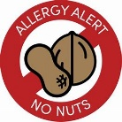  Lunch and snacks | - All pupils in Reception and Key Stage 1 are entitled to a Universal Free School meal. Pupils may bring a healthy packed lunch if they wish.  - Nursery pupils are able to purchase a meal or to bring a healthy packed lunch from home.  - We are a NUT FREE school. Please do not send your child to school with nut based products.  - Fruit will be provided to all pupils and milk will be provided to all eligible pupils.
Hygiene | - Regular handwashing is modelled and observed by staff.  - Hand sanitiser is positioned at entry and exit point across the academy and pupils will be supervised when using this.  - Enhanced cleaning of resources and environment takes place daily.  - PPE equipment will be used by staff when necessary.  - If a child falls ill with COVID symptoms, they will be placed in isolation (and supervised from a safe distance).
Behaviour Policy | - Please check our school website for our behaviour policy.  - Children will follow the school rules, ‘Be ready, Be respectful, Be safe’ at all times.  - Staff will praise children for following the school rules.
Self-isolating and Home learning | - Following the most recent government guidance individuals are not required to self-isolate if they live in the same household as someone with COVID-19, or are a close contact of someone with COVID-19, and any of the following apply:  - they are fully vaccinated  - they are below the age of 18 years and 6 months  - they have taken part in or are currently part of an approved COVID-19 vaccine trial  - they are not able to get vaccinated for medical reasons  - Any individual who does test positive must self-isolate for the recommended period of time.  - If at any point your child needs to self-isolate, please make the school office aware immediately. There is a government expectation that children complete the home learning set during this time. Staff will set home learning daily via your child’s portfolio on Class Dojo. Staff will also respond to home learning undertaken via Class Dojo.  - If children do not undertake home learning staff will contact parents.
Coronavirus | - The main symptoms of Coronavirus are: a new continuous cough, a high temperature or loss/change to taste or smell.  - We will all continue to follow Government advice, including track and trace advice, and self-isolate when required.  - Additional guidance can be found here - Stay at home: guidance for households with possible or confirmed coronavirus (COVID-19) infection - GOV.UK (www.gov.uk)  - In line with revised Government guidance, if a child tests positive for Coronavirus, their household and any close contacts should access a PCR test as soon as possible, but DO NOT need to isolate unless the test is positive, or they develop symptoms. HOWEVER, as an additional measure at Northwood Broom Academy, we are asking that children do not attend our academy whilst they are awaiting a PCR result. If a positive result is received, the child should continue to self-isolate as per Government guidance. However, if a negative result is received, the child may return to school but is advised to have a second test 4/5 days later but DO NOT need to isolate unless the test is positive, or they develop symptoms. This is in line with Public Heath England advice locally.  - Schools are no longer required to track and trace close contacts, and we are not required to close bubbles of close contacts.  - In the event of a child self-isolating, in line with Government guidance children will be expected to work at home
Communication | - The academy office is accessible via appointment only.  - Class dojo is the main platform for communication with parents.  - Parents are asked to ensure that they are signed up to Class Dojo before their child comes back to school as this will be our main method of communication.  - If you child is ill, this must be communicated directly to the school office.

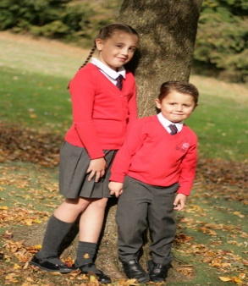  Uniform | PE kits for Key stage 1 children  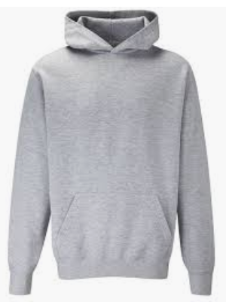  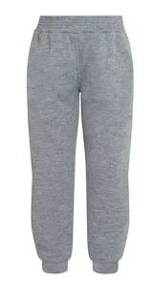 | 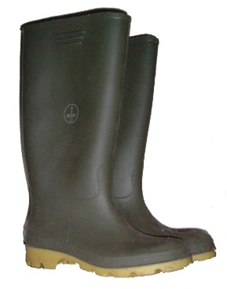  Wellies
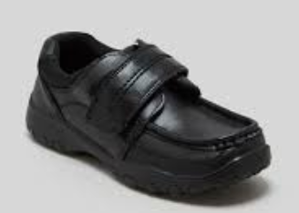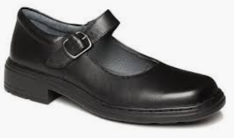  School shoes | 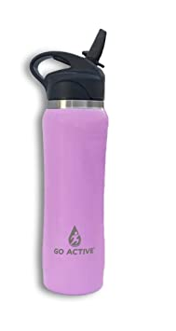  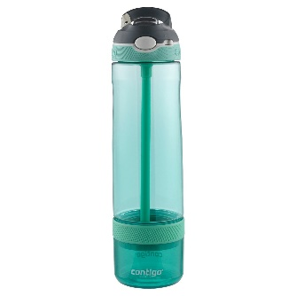  Sports water bottle | 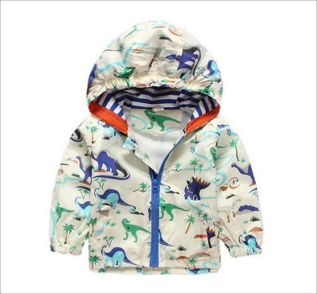  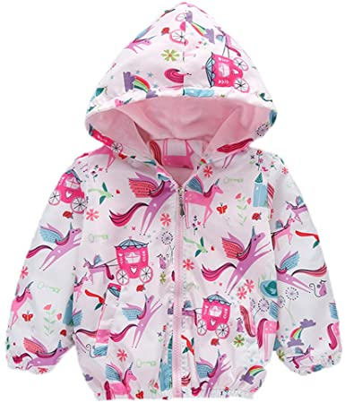  Waterproof coat
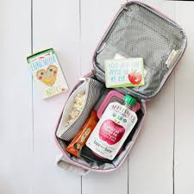  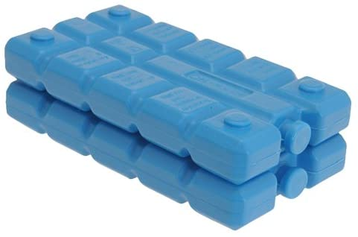  Healthy Lunch & Ice Pack if needed | 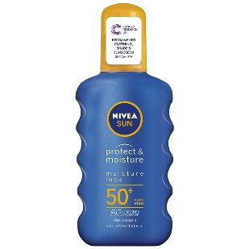  Sun cream | 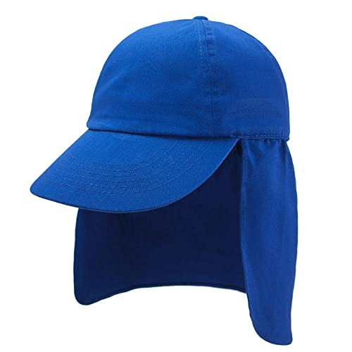  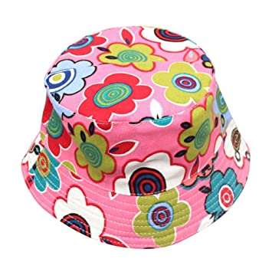  Sun hats

PARENT AGREEMENT:
I AGREE THAT I WILL FOLLOW THE GUIDANCE BELOW:

- Update school immediately if a member of my household becomes ill and immediately follow the self-isolation expectations.
- Should my child become unwell, with Coronavirus symptoms, I will obtain a test via 119, keep my child (and any siblings) at home whilst I await the results and inform the school as soon as possible of the test result.
- Ensure my child arrives promptly and is collected promptly at the times identified above. (I understand that staff will follow their attendance processes and may discuss my child’s absence and punctuality with me).
- Ensure that my child does not wear earrings to school.
- Ensure my child brings coats and wellies OR a sun hat and sun cream, so they can access outdoors in all weathers.
- Ensure my child brings their inhaler (which will be kept in school) and any other prescription medication/creams daily if required. (Only medication or cream prescribed from a doctor will be applied).
- Ensure up to date contact details for family members are available within school and emergency contact details should my child become poorly
- Treat staff with respect at all times.
- Ensure I communicate with class teachers through Class Dojo.
- Ensure my child brings their own packed lunch (if they are not eligible for a universal free school meal or free school meal), in a clearly labelled lunch box and include an ICE PACK to keep the lunch cool and any cutlery needed.
- Ensure I adhere to all of the expectations outlined in this document.

A message from Northwood Broom staff
Get your uniforms ready it's time for the new school year! We cannot wait to see you all face to face in school and to find out about all the exciting things you have been up to.
Please be assured that we have worked hard on all of the arrangements, in line with the updated Government guidance, to ensure everyone is kept safe. We will continue to deliver the very best education to your children both in school and remotely (if self-isolating).
As always, should you have any questions, recommendations or solutions we would love to hear from you.
Mrs Glaister, Mrs Brandrick and all the Northwood staff xxx

