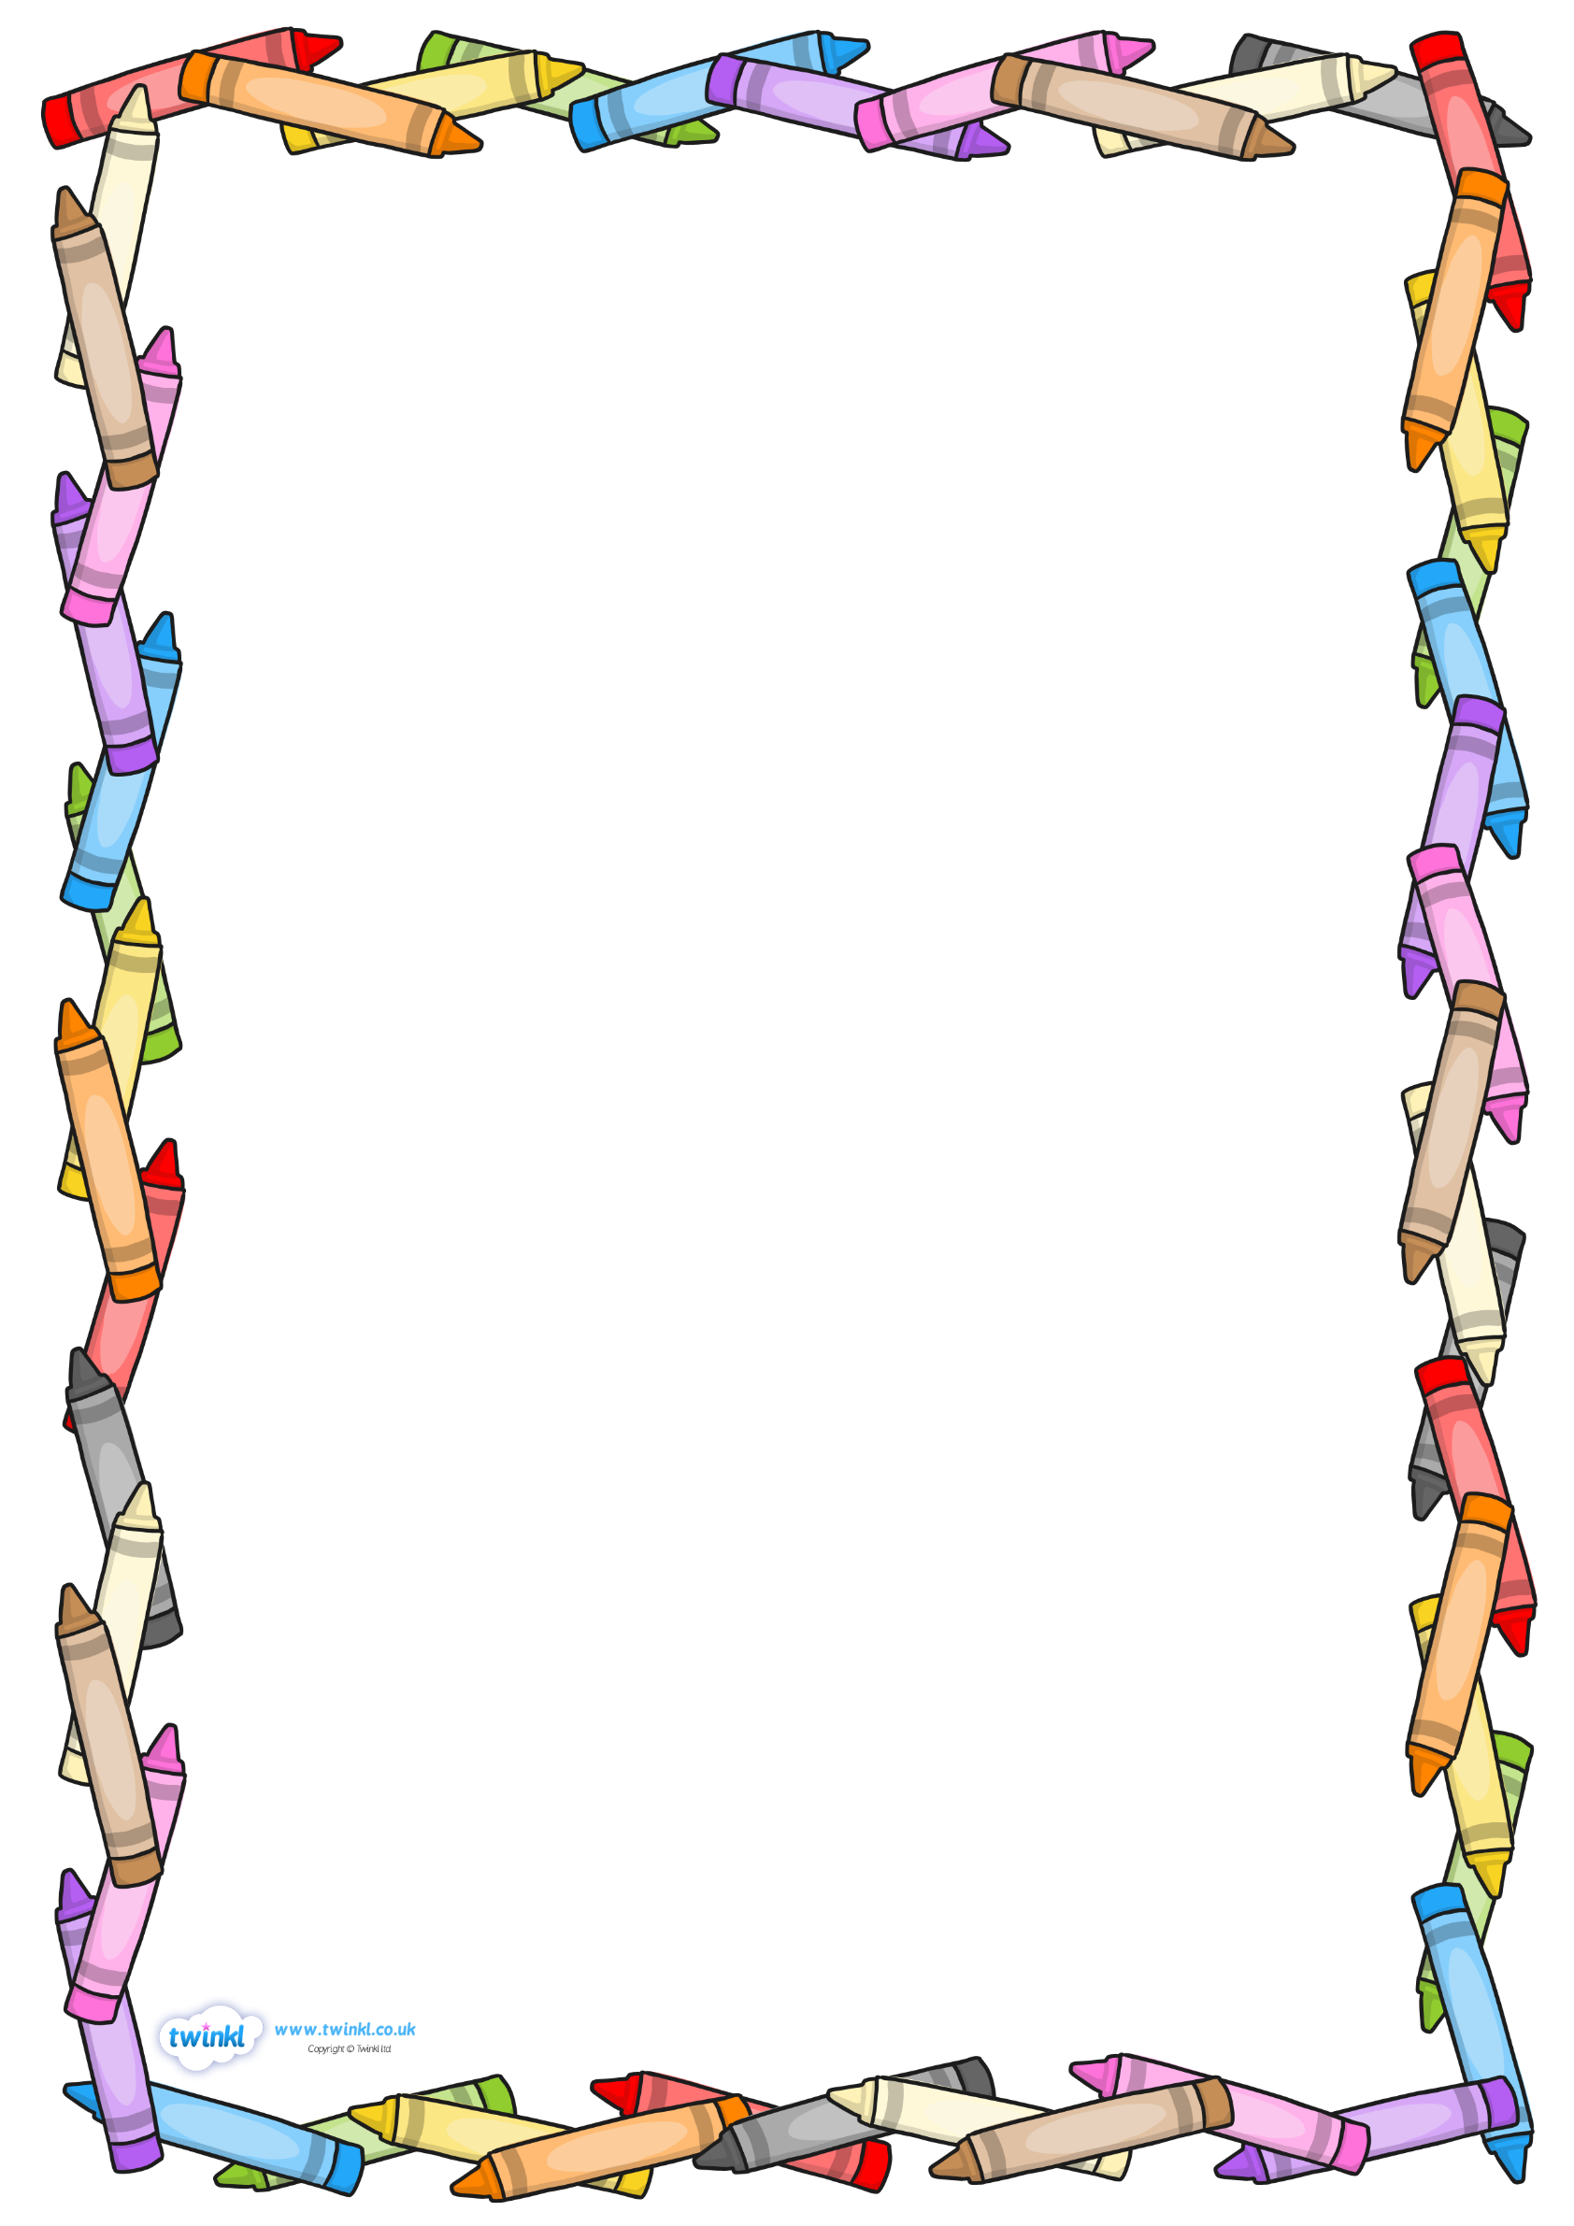
This week in Reception, we will be learning:
Maths:
We will be using the manipulation of concrete objects to add ‘more one’. We will be making ‘One more’ stories, for example;
First, I put 3 sweets in a bag, then I added one more, now I have 4 sweets in the bag.
Reading and Writing:
Your child will be learning a new sound every day. Ask your child about the sounds that they have learned and ask them to spot items around the house that begin with that sound.
Our new reading incentive starts this week so make sure that lots of reading is shared and that your child’s diary is signed.
Topic:
The children will be completing the first stage of their Art Triples this week. They will be using sketching techniques to draw an autumnal object. Could you go on a hunt for some autumn objects and talk about what makes them interesting?
The children will receive a visit from some special people who help us such as a Police Officer. We will be asking these special people lots of questions about their roles, could you help your child to think of some questions to ask in preparation for our special visitors?

