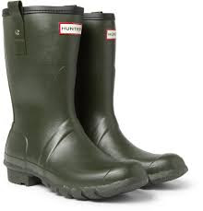

**PE Kits**

PE will take place on Tuesday. Please ensure that your child brings their PE into school on the first day back after each half term. PE kits will be sent home at the end of each half term to be washed.

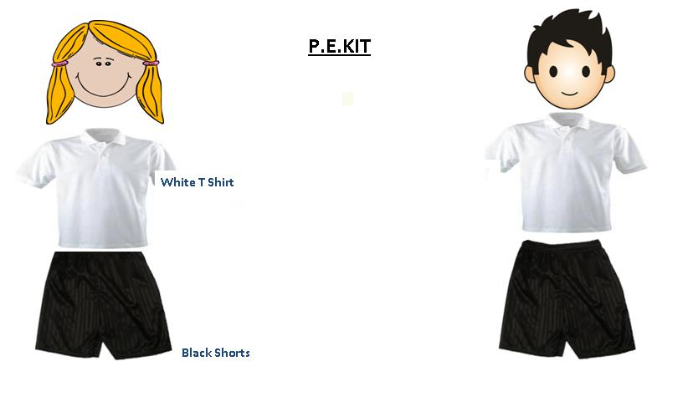

Don’t forget…

All items of clothing need to be clearly labelled with names.

**Vocabulary**

Key vocabulary that we be learning this term. Ask your child to show you or tell you what each word means.

mother, baby, summer, playing, sleep, tired, morning, dream, bedtime, goodnight, hug, near, world, moon, midnight, dark, sister, brother, little, big, tricycle, grew, seasons, Summer, Winter, Autumn, Spring, sun, hot, cold, rain, leave, hot, cold, warm, clothes

**Forest School**

May we remind you that children need to bring in extra clothes for Forest School each week. These should be suitable for the weather and include a pair of wellingtons. Children with **waterproof all in one suits** will be able to take part in mud sliding!

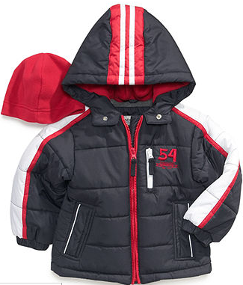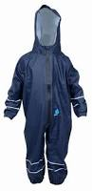

Dalmatians HS

Autumn Term

**Homework**

Homework will be set every Wednesday and will be live until the following Monday. Please support your child to complete their homework as it allows the children to apply what they have been learning at school.

<https://ec1.educationcity.com/?_ga=2.122751945.358373069.1552496471-438602286.1543237139>

**Half Termly Challenges**

This term the homework challenges are;

|  |  |
| --- | --- |
| Autumn 1 | We have been learning all about ourselves. Can you draw a picture of your family and label it.  Bring in the picture that you create. |
| Autumn 2 | We have been on a leaf hunt at school. Can you go on a leaf hunt at home and create a picture with these. You could create an animal, a person or even a pattern.  Bring in what you make or take a picture. |